Lab4
Alex McLaurian
3/1/2014
- I used the recommender system class from the tutorial against a small sample of data from the dataset used in my project, which is a crime dataset. I wanted to look for possible connections between various hours and types of crimes. For the id, I used the hour, rounding to the top of each hour, and using military time instead of AM and PM (0000-2400). For the title, I took the original crime descriptions, and converted them to integers. I modified the tutorial recommendation system code and used formatted the findings into a JSON file.
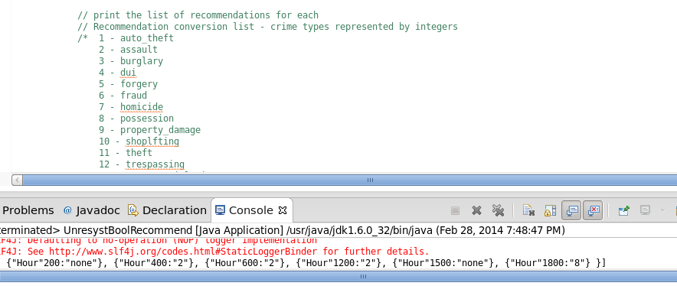
- The second task was to develop a mobile application using Solr’s REST functionalities. I modified the Rest services from the previous tutorials, using the upload function to upload my JSON file to my Virtual Machine’s Solr. Additionally, I added a web service that allows you to query the Solr engine based off of crimeId (title), so you can see the corresponding times (IDs) they took place.
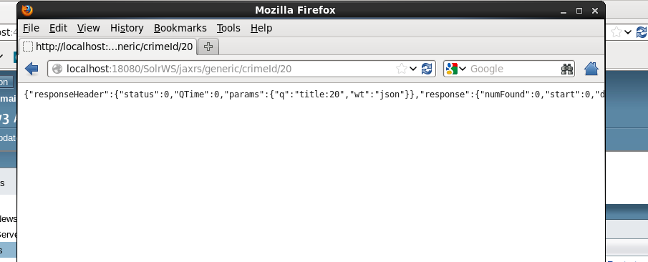
The web service was developed using Eclipse and JAX-RS, with the home page interface designed with Twitter bootstrap and JQuery.
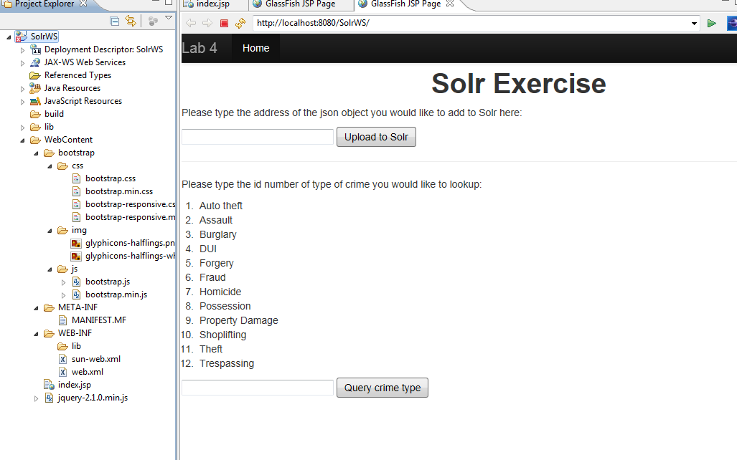
Adding the rest service onto the Virtual Machine’s glassfish proved challenging, as Glassfish had port connection issues, and testing Solr’s capabilities with curl proved to be a tough task as well, as the various options and filters for queries made it a challenge to get the proper response from Solr. Overall, the lab proved to be a good experience and helped me get more comfortable with the various moving parts that will be required to develop a good project.

